PRESS RELEASE: Torrefied Wood Pellets – the renewable energy fuel of the future.
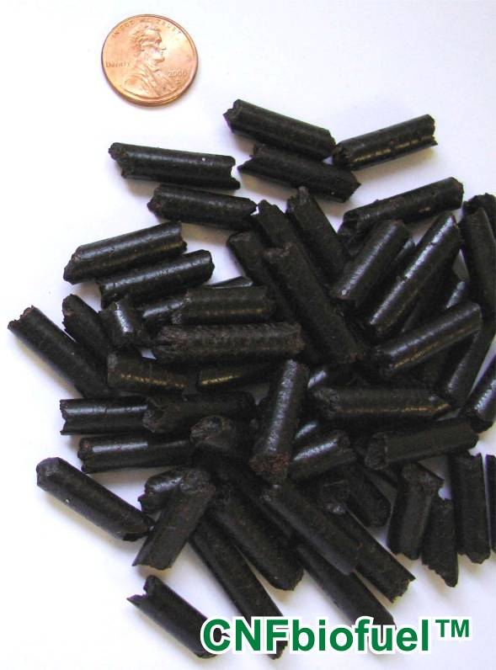
CNFbiofuel, Inc. of Salida, California received U.S. Patent No. 8,217,212 on July 10, 2012 on a new Torrefication method of processing biomass into a useful fuel. The name of the patent is SEQUENCING RETORT LIQUID PHASE TORREFICATION PROCESSING APPARATUS AND METHOD . We now have multiple patents and patents pending.
Biomass is the most practical and abundant form of concentrated solar energy. If properly conditioned to burn clean, it has the potential to substantially offset fossil fuel use. The cleanest form of solid biomass is torrefied wood pellets.

The new Torrefication technology uses liquid conduction heating with a high temperature heat transfer fluid. Pelletized biomass is completely immersed in a heat treatment fluid at multiple temperatures within closed reactors. This results in fast processing and virtually no air pollution released by the biomass. All generated vapors are routed through a condenser, and reclaimed liquids like cedar oil may have commercial value that can help cover the cost of the process.

Unlike prior Torrefication systems, the biomass is pelletized prior to processing. This results in less transport cost, smaller equipment, faster and more uniform processing and low overall costs, 24/7 operation, no torrefied dust or fire problems, and few moving parts to wear. The finished pellets contain a small amount of heat transfer fluid resulting in high energy content, clean burning, friable and hydrophobic Enhanced Torrefied Wood Pellets or CNFbiofuel™.

CNFbiofuel™ can be co-fired with existing coal fired power plants without any shut-down or structural plant modifications. The new fuel can be used as feed-stock for gasification systems and combination heat and power CHP systems. Systems can use a small portion of the pellet output as fuel for all processing needs. No outside power source is needed.
Several small scale test stands have processed a variety of wood pellets into high quality torrefied wood pellets and independent testing laboratory show positive results. The next step is construction of a larger portable pilot unit to prove scalability before building commercial size units. This emerging technology could convert tree pruning, grasses, agricultural waste, forest thinning, energy crops and other forms of waste biomass to clean electric energy.
The social and economic potential for this new technology is enormous. Just one 550 MW coal fired power plant converting to 100% torrefied wood pellets will require over 2,000,000 tons per year. Torrefied wood pellet costs are not yet well established and may vary widely depending on location, quantity and many other factors. Cost estimates may range from $120 to $ 200 per ton. With very large quantities, government incentives and with on site processing using waste heat from the power plant, the cost may be close to that of natural gas. Older coal fired plants that faced shutting down may instead co-fire 20% to meet environmental regulations without any long periods of downtime or costly upgrades. The benefits include generating over a hundred million dollars into the local economy and much needed jobs and new industries. Growers, harvesters, transportation, pellet mills, processing equipment and many support businesses should see steady long term growth. The environment would improve by keeping the coal in the ground and using renewable energy for a win win situation.
Now that the Intellectual Property has been secured with positive tests that show proof of concept, we are interested in partners to help with ongoing development to bring this emerging Torrefication Equipment, Product and Technology to the marketplace. This includes licensing and providing demonstration and pilot projects that lead to commercial size processing equipment.
Contact: John A. Paoluccio PE, President
CNFbiofuel, Inc. an associated company of Inventive Resources, inc.
PO BOX 1316, 5038 Salida Blvd., Salida, CA 95368
Ph: (209) 545-1663, Fax (209) 545-3533
Email: info@CNFbiofuel.com Web: www.CNFbiofuel.com

